

CM VERSION 2

PROTOTYPE WALKTHROUGH

Brian Chege | Web Development | 29th/Oct/2021

# About the Website

CM Website Version 2 is a system upgrade of cm portal version 1. The existing system (version 1) had certain features such as consultation and purchase of products such as documents, features which are made more seemless in version 2. As of end of October, the User Interface has been developed, subject to approval by the product owner.

The structure of the website has the following skeleton:

1.The first user(super admin) .This is the user that is responsible of controlling information that is added or removed on the website .

2. The second user (the Client). This is the user who seeks services on the website. The client has a members’ area that enables them to keep track of services that he/she has purchased in form of subscriptions or as a one-time transaction user. This also gives the client a secure manner of performing certain operations such as updating their profiles or downloading documents that they have access to, as well as benefits of packages they are subscribed to.

3. The third user (advocates profile) – This is part of the software where the advocates receive the clients’ requests such as consultation or documents review and can keep track of clients that access any type of services.

## The users are described in detail below:Super admin

As aforementioned, this user is responsible of controlling the information on the website. by performing CRUD operations (Create, Read, Update and Delete). The CRUD operations helps make the site moredynamic and easily adopt future modifications, i.e., if one wants to change the consulting hours offered in a certain subscription , which is known as updating a module. Anything that will be highly dynamic can be handled now with this new module. This user can also perform analysis on certain data on the website, for instance, getting the total number of documents purchased in CM SME or in Legal Documents Portal and the corresponding graphs that give clear visualizations of the data that is being collected.

## CLIENT(MEMBERS AREA)

This is the end user accessing the services that the website is offering. The Member’s area is where the client is able to access services only after authenticating with the system which are basic security protocols. In case a client purchases a document, they are able to keep track of the document with details such as the name the date of purchase, or in case of SME Club, they are able to keep track of documents, consultation hours and videos that they have access to. The profile (Members Area) will also enable the user to perform certain operations such as purchasing a subscription in a secure manner.

The client will also be able to book for a consultation by use of google meet and audio call as modes of communication. Once they book a slot from integrated calendars of the advocates’ available time, then the respective advocate associated with the practice area and the lawyer type the client selects will receive emails and attend to the client accordingly.

ADVOCATES’ DASHBOARD

This part of software will enable the advocates to view clients accessing services such as documents review. They will be able to perform some functions similar to the admin, for example, CRUD functions where the advocate will be able to respond to the client or view a client who has defaulted payment on any of the services or subscriptions. The lawyers will be able to save some information in various formats such as pdfs or in excel format.

Other features such as purchasing a product or a consultation are inherent from version 1. However, some modifications will be made for instance in the cart when the client is purchasing document the system should do checks or perform constraints and have some mailing functionality of accessing the document.

**The super admin (web pages)**

How to access the admin first authenticate with the system

Use the following credentials email: [CMAdvocatesadmin@gmail.com](mailto:CMAdvocatesadmin@gmail.com)

Password: admin

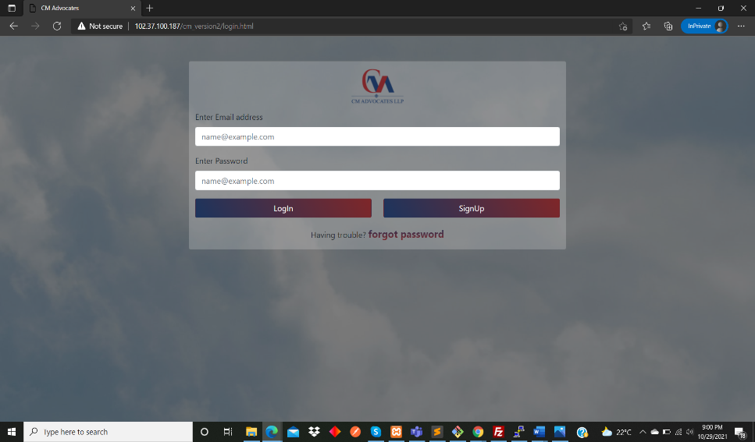

Updating the admin profile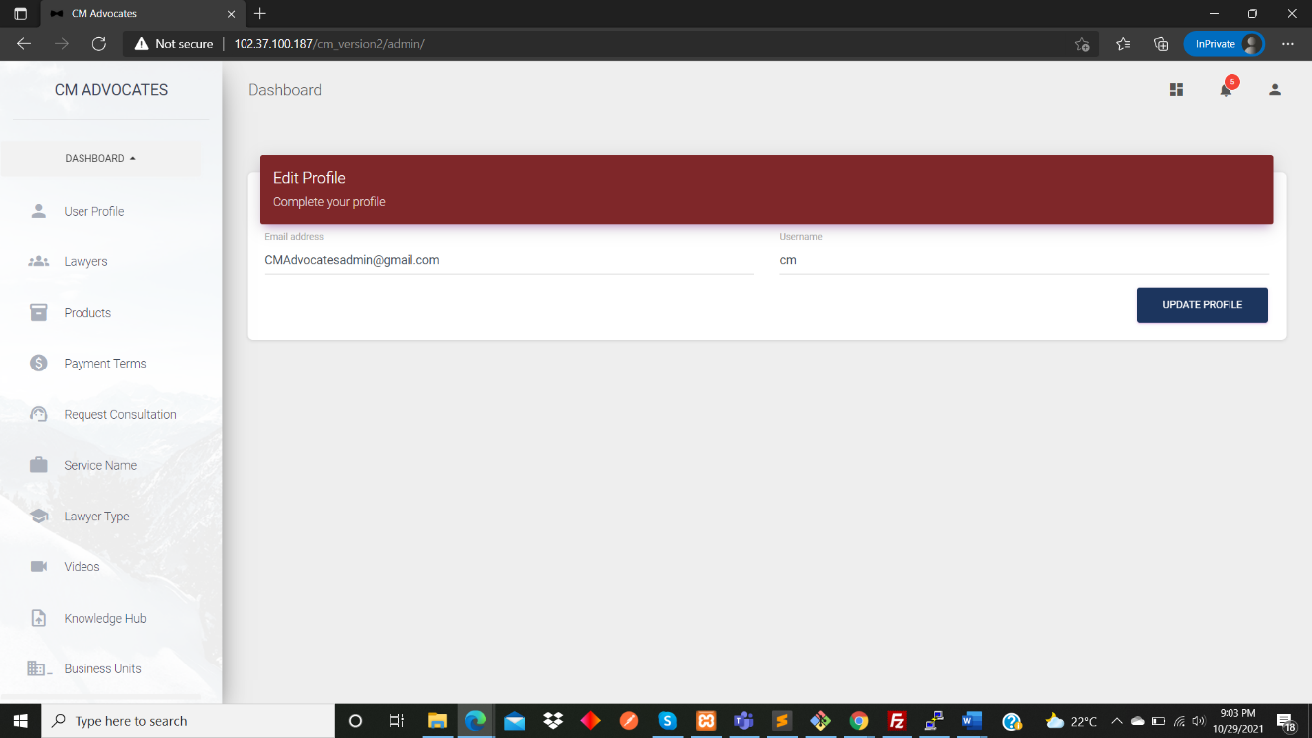

Adding advocates

The admin will be adding features of a subscription.

The admin will be posting videos or editing and choose which subscription or service should the video be entailed in

Admin adding the practice area or edit or view such as associate in this case

Admin adding the lawyer types or edit or view such as associate in this case

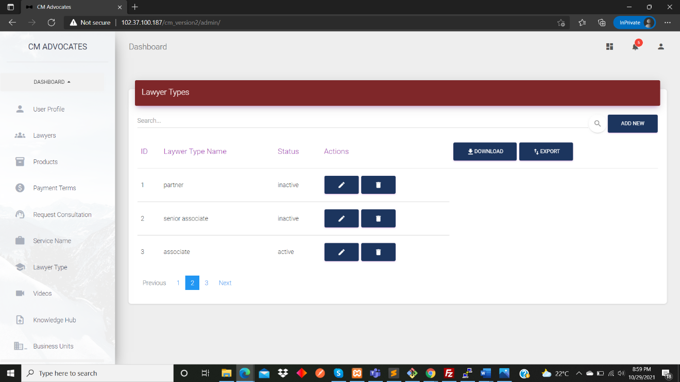

The admin adding documents that can be mapped to a subscription such as standard in SME Club or in a service such as legal documents portal

**The Client’s Members’ Area (web pages)**

The client will also be accessing the system through the same login page.

Credentials are for a client : email : [mugoethan78@gmail.com](mailto:mugoethan78@gmail.com)

Password: pass

Updating the client profile

Where the client will view the subscriptions to purchase

After a client purchases a subscription

The client being able to view the documents accessible in the subscription or that are not in that subscription

These snapshots should be used as a guide in navigating through the site.